Shotgun Boogie Trigger Kit
includes 9 pieces
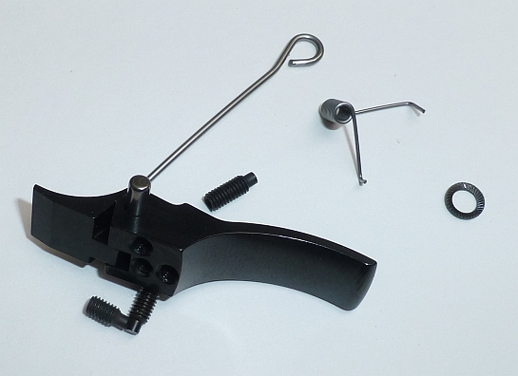
Upper trigger
Lower trigger
Washer ( instead of the flat safety bar spring )
New safety bar spring
New trigger spring
New pin
Three screws, metric M3.

Hexkey 1.5mm needed.
Cut a piece of 9mm from the old trigger/sear pin. This you can use as a slave pin for much easier installing.
Before you start using loctite or nail polish for all three screws, play a little bit with the trigger group and adjust trigger kit in the lower tang.
When you have the lower tang out, disassemble all trigger parts including springs. Leave only the safety bar in the lower tang. Then set the screws with loctite or nail polish. If you look from front to back, lowest screw is the trigger stop backwards. Right screw trigger stop forward. Middle and shortest screw play between the two parts. Assemble trigger. After that, please build safety bar spring in. Now the trigger spring and washer ( the screw press washer on the spring ).

One screw is the trigger stop forward. This screw must be adjust from behind. It is the first screw you have to adjust. The safety bar must be able to come out of the frame, but no play on the trigger.
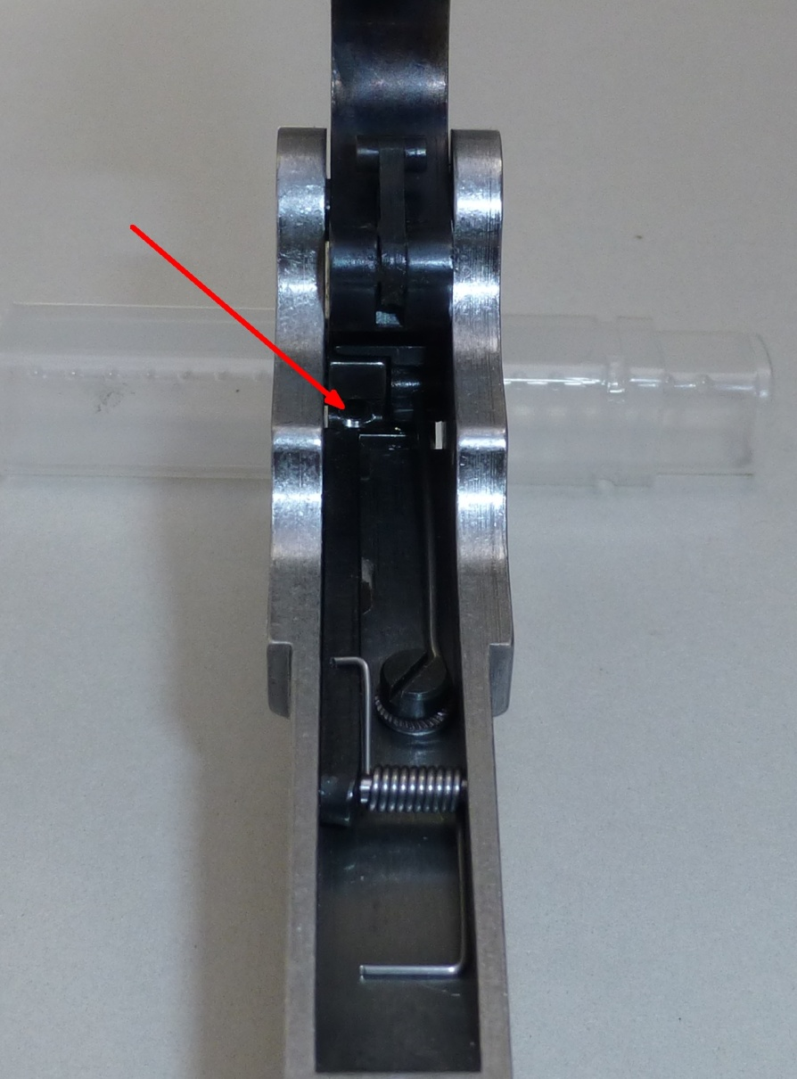
Next step is to adjust second screw, the play between upper trigger and lower trigger. At that point the third screw for trigger stop backward must be complete inside the trigger! Otherwise you can’t reach screw number 2.
Take care that hammer is NOT going down when pulling trigger. And when pushing the safety bar into the lower tang, like the closed lever is doing, the trigger may not move backwards.

At last adjust third short screw for trigger stop backward.
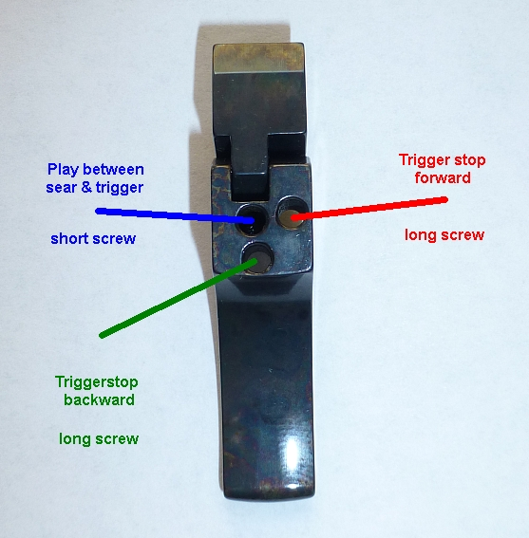

At first adjust the trigger stop forward, that the safety bar just can slip behind the trigger, without play.
Then adjust the play between the two parts, that the hammer stay in cocked position, when safety bar is behind trigger and you pull trigger. When you push the safety bar into the lower tang (like the closed lever do), trigger does not have to move. Then adjust trigger stop backwards to the shortest possible way of trigger.

When you have questions, please ask.

