How to install a Ruger Short Stroke Kit
- disassembly the Ruger complete
- mark the recoil plate carefully. You need it for assambling
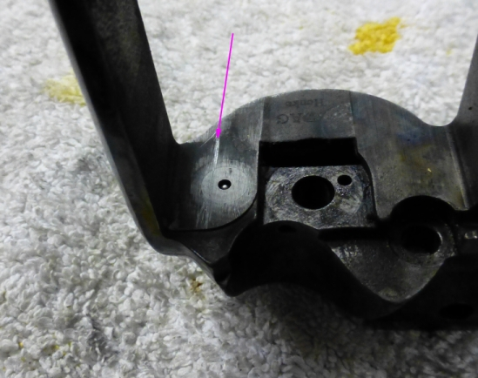

- start to punch out the cross pin with starter
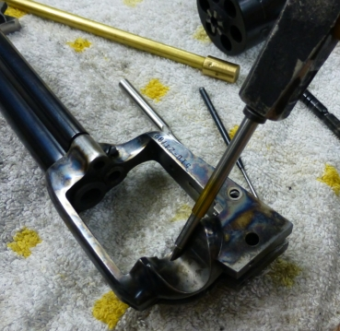
- when it is loose, take a longer pin and punch the crosspin complete out.
- punch the firing pin out
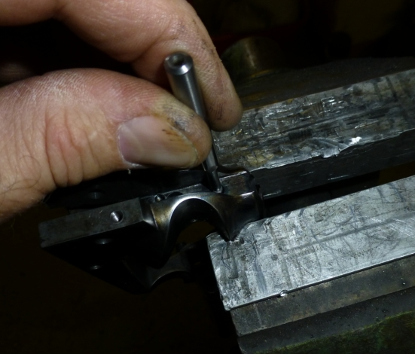
- change the firing pin spring and assamble the firing pin, spring and recoil plate. Please use the long rod thru the barrel. Look at the marks on the recoil plate, that they are on the right place. Take care, that you don’t demage the firing pin!

- file the burr inside the frame away
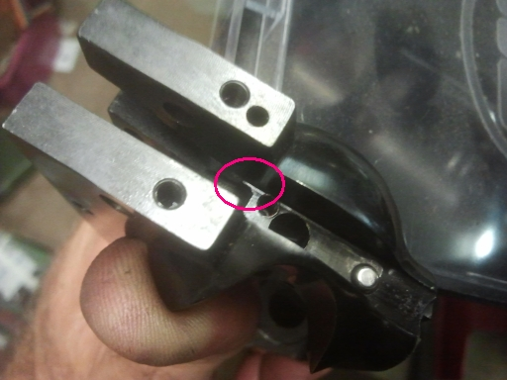

- grind material like the purple line shows, NOT only the edge in 45° !

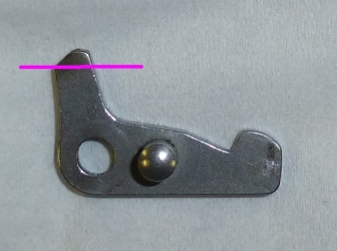

- put all tuning springs insteed of the original ones into the frame.
- assamble all. You can start with latch and trigger, or with hammer and pawl.
- hammer strut and spring can be the last parts together with hammerstop.
- adjust the hammer stop.

